

**Smart energy meter for enhanced electricity management that monitors electricity used by all components and automatically disconnects components using high voltage**

By

KITAKA JASPER GIDEON 2021/EEE/063/PS

AYEBARE ALVIN 2021/EEE/036/PS

ABAHO TIMOTHY 2021/EEE/001/PS

DEPARTMENT OF ELECTRICAL AND ELECTRONICS ENGINEERING  
FACULTY OF APPLIED SCIENCE AND TECHNOLOGY

|  |  |
| --- | --- |
| 2021eee063@std.must.ac.ug | 0758599757 |
| 2021eee001@std.must.ac.ug | 0740341940 |
| 2021eee036@std.must.ac.ug | 0778971433 |

A Project Report of Smart Energy Meter Submitted to the Faculty of Applied Science and Technology for the Study Leading to a Project in Partial Fulfillment of the Requirements for the Award of the Degree of Bachelor of Electrical and Electronics Engineering of Mbarara University of Science and Technology.

# APPROVAL

1. **PROJECT SUPERVISOR**

**Name ………………………………………………………………….**

**Signature…………………………………………………………..**

1. **University project coordinator**

**Name……………………………………………………………………..**

**Signature………………………………………………………………**

# Declaration

**I hereby declare that all the contents in this PROPOSAL REPORT is our own work, obtained from research carried as a group and has never been submitted for any academic purposes. Any work that does not belong to us will dully be referenced.**

**Name ……………………….**

**Signature…………… ………. Date………………….**

**Name ………………………….**

**Signature …………………….. Date………………….**

**Name …………………………..**

**Signature………………………. Date………………….**

# ABSTRACT

This project focuses on the creation of a Smart Energy Meter, designed to intricately detect and monitor the electricity usage of individual components within a system. The overarching goal is to meticulously identify and manage power-intensive components, thereby optimizing overall energy efficiency. Our approach integrates cutting-edge sensor technology and real-time data analysis, providing a detailed and comprehensive overview of electricity usage patterns. The system is adept at recognizing elements with high power consumption, and it employs automated measures to mitigate excessive energy use. By leveraging these innovative technologies, our project strives to make significant contributions to sustainable energy practices, fostering efficiency and conservation in electricity consumption across a diverse range of applications and environments.

Table of Contents

APPROVAL 1

Declaration 2

ABSTRACT 4

Introduction: 6

Background: 6

Problem statement 6

General Objective: 7

Specific Objectives: 7

Research questions. 8

Project Significance: 8

Value Proposition: 8

Innovation: 8

Impact: 9

Business Component: 9

Scope 9

CHAPTER TWO 10

Literature review 10

2.1 Introduction 10

2.2 Literature Review: Designing Prototypes for Real-Time Electricity Usage Data Collection 10

Literature Review Summary: Modeling Systems for Enhanced Billing Accuracy and Efficiency 10

2.4 Literature Review Summary: Empowering Consumers for Responsible Energy Use through Smart Meter Data 11

CHAPTER 3: 12

METHODOLOGY 12

3.0: Introduction 12

3.1 Sampling techniques 12

3.2 Study population and sample size 12

3.3 Data Collection Procedure 12

3.4 Data processing and analysis 13

3.5 Data presentation and interpretation 13

3.6 Limitation of the study 13

References 14

# Introduction:

Access to reliable and affordable electricity is a fundamental driver of socio-economic development in Uganda, as well as in the broader East African region. As the demand for electricity in Uganda continues to grow due to population expansion, urbanization, and industrialization, it has become imperative to modernize and enhance the efficiency of the existing electricity infrastructure. This project proposal outlines the plan to implement smart energy meters in Uganda, with a focus on their functionality and benefits in the context of the country's energy landscape.

# Background:

The United States has seen significant adoption of smart energy meters. Various utility companies and cooperatives across the country have deployed these meters to provide real-time data on electricity usage to consumers. The U.S. federal government, through initiatives like the American Recovery and Reinvestment Act of 2009, provided funding to accelerate the deployment of smart meters as part of the broader smart grid effort [1].

Uganda, a landlocked nation in East Africa, has made significant strides in expanding its electricity generation capacity in recent years. The country's energy sector, largely dominated by hydropower and thermal sources, has shown promising growth [2]. However, despite these advances, challenges related to electricity distribution, billing, and management persist. Power losses, inefficient billing systems, and difficulties in monitoring and controlling electricity consumption remain prevalent issues. These inefficiencies not only result in financial losses for both consumers and utility companies but also hamper the nation's ability to provide electricity access to all its citizens [3].

Smart energy meters represent a transformative solution to these challenges. They offer the capability to accurately measure electricity consumption, provide real-time data, and enable two-way communication between consumers and utility providers. In East Africa, where many households and businesses still rely on pre-paid electricity meters or conventional meters with manual reading, the introduction of smart meters promises to revolutionize the electricity landscape [4].

# Problem statement

Uganda, located in the heart of East Africa, has made commendable progress in its electricity generation and distribution infrastructure over the past decade. The country's power generation capacity has expanded significantly, primarily driven by hydroelectric sources. Despite these achievements, the electricity sector in Uganda continues to grapple with several critical challenges that hinder its full potential. These issues are emblematic of broader challenges faced in East Africa, and their resolution holds immense significance for the region's socio-economic growth [5].

These are part of the problems that smart energy meters can be able to solve if given the attention and funding,

Metering Issues: Conventional meters lead to billing errors, causing financial disputes. Manual meter reading processes contribute to inaccuracies, with studies indicating error rates as high as 20% [6].

High Energy Losses: There are technical and commercial losses due to outdated technology and unauthorized connections, impacting revenue and rural electrification efforts. Uganda experiences energy losses of approximately 23%, significantly higher than the global average of around 6% [7].

The problems outlined above have far-reaching implications for Uganda and East Africa as a whole. They hinder economic growth, discourage foreign investments, affect the quality of life for citizens, and impede efforts to combat climate change.

## General Objective:

We designed a prototype that will enhance electricity management and billing efficiency in Uganda and East Africa through the implementation of smart energy meters.

## Specific Objectives:

* ‌We modelled a well-structured system that will improve billing accuracy and efficiency by implementing time-of-use billing systems, reducing billing disputes, and streamlining revenue collection processes
* ‌We designed a prototype that will be enable mobility and friendliness in use.

## Research questions.

1. How can the deployment of smart energy meters in Uganda and East Africa improve electricity-billing accuracy and reduce disputes between consumers and utility companies?
2. What are the technical and operational challenges associated with the implementation of smart meters in East Africa, and how these challenges can be mitigated to ensure a successful rollout.
3. To what extent can the integration of smart meters in Uganda lead to a reduction in technical and commercial losses in the electricity distribution system, and what strategies are most effective in achieving this reduction?
4. How do smart energy meters empower consumers to monitor and manage their electricity consumption, and what impact does this have on energy conservation efforts in Uganda and East Africa?

## Project Significance:

Enhancing Electricity Management in Uganda and East Africa through Smart Energy Meters

## Value Proposition:

The implementation of smart energy meters in Uganda and East Africa offers a multi-faceted value proposition that addresses critical issues within the electricity sector:

Smart meters eliminate human errors in meter readings, leading to more accurate and transparent billing processes. This not only reduces financial disputes but also fosters trust between consumers and utility companies.

Smart meters empower consumers by providing real-time data on electricity usage. This knowledge allows individuals and businesses to make informed decisions about their energy consumption, leading to cost savings and environmental sustainability.

Smart meters enable the identification and mitigation of technical and commercial losses in the distribution system. This results in increased revenue for utility companies and cost savings for consumers.

## Innovation:

This project provides a much-needed upgrade in the regular meters and some of the innovative ideas it would bring to the table include;

The introduction of smart meters represents a technological leap forward in the management of electricity. These meters use cutting-edge technology to provide real-time data and two-way communication, enhancing the efficiency and reliability of the grid [8].

Smart meters harness data analytics, allowing for the intelligent utilization of information related to electricity usage patterns. This approach empowers both consumers and utility companies to make data-driven decisions, fostering a culture of energy conservation.

## Impact:

This project is highly impactful as it aims towards proper consumption of electricity units and this is how its impact can be further elaborated.

Improved electricity management and billing accuracy create a stable environment for businesses, encouraging investment and job creation.

Smart meters empower consumers to take control of their energy usage, leading to savings, economic stability, and enhanced quality of life.

## Business Component:

The implementation of smart energy meters in Uganda and East Africa presents viable business opportunities.

Leveraging smart meter data, businesses can provide data analytics services, energy management solutions, and customer support to both consumers and utility companies.

The project's capacity-building component creates employment opportunities in the installation and maintenance of smart meters, contributing to local economic development.

Utility companies benefit from reduced operational costs associated with manual meter reading and a decrease in technical and commercial losses.

In summary, this project not only addresses critical challenges in the electricity sector but also presents substantial opportunities for business development and innovation, while positively impacting the economy, the environment, and the well-being of the people in Uganda and East Africa.

## Scope

This research is aimed at the assessment of manual energy meters mainly focusing on electricity in Uganda and the design of a smart energy meter based on a real world study. This area of case study is intended to provide local homesteads the ability to keep track of their energy consumption and know how to spend on the energy appropriately.

# CHAPTER TWO

# Literature review

## 2.1 Introduction

This chapter embarks on a journey, drawing from the wealth of research conducted in the field. By critically reviewing related works, theories, and research findings, we aim to get insights, contribute to the existing knowledge base, and bridge the gaps and weaknesses that propel our unique project forward.

Smart energy metering systems have emerged as crucial tools for enhancing energy efficiency and promoting sustainable consumption practices. This literature review aims to explore significant contributions from prominent engineers and researchers in the field of smart metering technologies.

**Dr. George W. Arnold**:

In his book "Smart Grids: Clouds, Communications, Open Source, and Automation," Dr. Arnold discusses the integration of cloud computing, communication technologies, and open-source platforms in smart grid infrastructures. His work emphasizes the importance of interoperability and scalability in deploying smart energy metering solutions.

**Dr. Arun G. Phadke and Dr. James S. Thorp:**

Phadke and Thorp's seminal paper "Synchronized Phasor Measurements and Their Applications" presents advancements in synchronized phasor measurement techniques for monitoring and control applications in power systems. Their research laid the groundwork for real-time monitoring capabilities essential for smart energy metering systems.

**Dr. Massoud Amin:**

Dr. Amin's research on "Smart Grid: Infrastructure, Technology, and Solutions" provides comprehensive insights into the architecture, technology, and deployment strategies of smart grid systems. His work highlights the role of advanced metering infrastructure (AMI) in enabling two-way communication and data analytics for efficient energy management.

**Recent Advances and Research:**

**Dr. Raja Jurdak and Dr. Salman Durrani:**

Jurdak and Durrani's article "Non-Intrusive Load Monitoring for Residential Electricity Consumption: A Survey" offers a comprehensive overview of non-intrusive load monitoring (NILM) techniques for disaggregating household energy consumption data. Their survey encompasses various algorithms and approaches for identifying individual appliances based on aggregate power readings from smart meters.

**Dr. Kankar Bhattacharya and Dr. Krishnan Rajeshwaran:**

Bhattacharya and Rajeshwaran's research paper "Demand Response in Smart Grids: A Review of Technologies, Strategies, and Challenges" investigates demand response strategies and technologies for optimizing energy consumption and grid stability. Their work addresses the integration of smart meters with demand response programs to incentivize consumers for load shifting and peak shaving.

The works highlighted in this literature review underscore the multidisciplinary nature of smart energy metering systems, encompassing aspects of power engineering, communication technologies, and data analytics.

# CHAPTER 3:

# METHODOLOGY

## 3.0: Introduction

The design of the project was as follows: a printed circuit board where all the connections were made. A bluetooth module that was used for connecting the phone to the Arduino, the voltage sensor for measuring the voltage of the appliances,a current sensor to also measure the current used by the different appliances, connecting jumper wires, LCD screen, Arduino UNO.

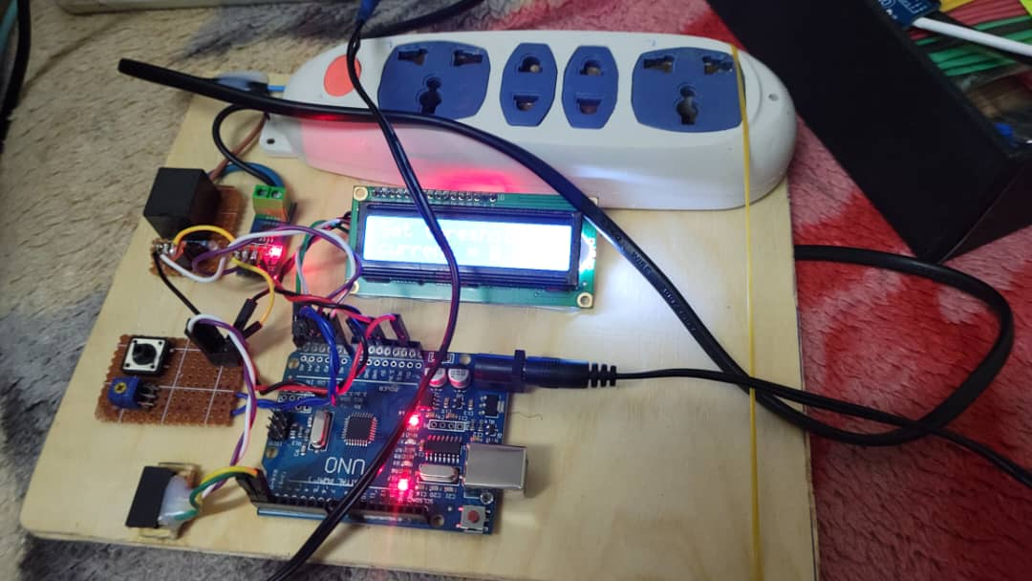

The setup was connected to an extension cable with multiple ports where our appliances are plugged into the extension cable ports. The voltage usage of our appliances is viewed on the mobile application. The code is input into the Arduino IDE with the amount of electricity to be used for a specific period. When fully connected, the system was able to allow us set a certain amount of electricity we would wish to consume in a given period and when surpassed disconnect the devices connected along the extension cable. The system with the help of the Bluetooth module is able to enhance mobility and also cater for the record keeping as the amount of electricity being used at a certain instant is kept track of. In this case, the user is able to save and also plan on the expenditure on electricity accordingly.

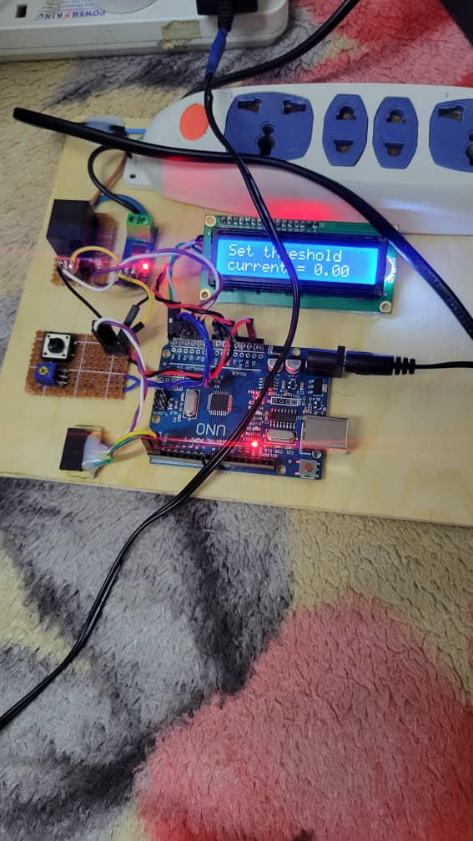

## BUDGET

|  |  |
| --- | --- |
| ITEM | AMOUNT |
| ADUINO UNO | SHS.85,000 |
| HC- 05 | SHS.50,000 |
| CURRENT SENSOR | SHS.55,000 |
| VOLTAGE SENSOR | SHS.40,000 |

## 3.1 Sampling techniques

Judgmental and non-probability sampling was used to locate 25 informants. All individuals participating in the study were given an equitable opportunity for inclusion within the sample. The methodology employed for this purpose was simple random sampling, and it was implemented within a population characterized by homogeneity, where all members shared identical attributes of interest to the researcher. The sampling process was designed to ensure a uniform and unbiased representation of the entire population under investigation, minimizing any potential patterns or biases that could arise from the selection process.

## 3.2 Study population and sample size

Three University students carried out the study in Mile 3. The study covered 6 homesteads and 4 business owners in Mile 3. The study population in these clusters included 2 chapatti vendors, 3 house wives, 4 shop owners, 2 house helps and 1 barber. Around 12 informants were engaged to obtain trustworthy information concerning discrepancies present in the existing record-keeping system.

|  |  |  |
| --- | --- | --- |
| Categories | Population | Sample |
| Chapati vendors | 16 | 2 |
| Small business owner | 12 | 4 |
| Hardware owner | 6 | 1 |
| Housewives | 12 | 3 |
| Barbers | 8 | 1 |

## 3.3 Data Collection Procedure

We interviewed the informants asking them the following questions: Are they ok with the current household metering process? How they are able, regulate the amount of electricity used in the household? What are the highest power consuming appliances in the household? What would they need in order to regulate the amount of electricity used in the household?

## 3.4 Data processing and analysis

We used Microsoft Office excel to tally the numerical Reponses of the informants with also a pen and paper to write down their reactions.

## 3.5 Data presentation and interpretation

After, all the information acquired was, it was typed in Microsoft Office Word including the tables showing the statistics.

## 3.6 Limitation of the study

We incurred many problems including the following:

* Language barrier as many of our informants did not know English but only knew the local language Runyankole.
* Some informants were not clear with their responses.
* Other informants were harsh and did not want to be interviewed.
* Long distances moved while conducting the interviews
* Inadequate funds for lunch and transport.
* Harsh weather conditions. It rained for most of the time as we were conducting the interviewer

# References

|  |  |
| --- | --- |
| [1] | [Online]. Available: https://www.ncbi.nlm.nih.gov/pmc/articles/PMC9963122/. [Accessed 8 November 2023]. |
| [2] | [Online]. Available: chrome-extension://efaidnbmnnnibpcajpcglclefindmkaj/https://www.iied.org/sites/default/files/pdfs/migrate/16030IIED.pdf. [Accessed 8 november 2023]. |
| [3] | [Online]. Available: https://www.hindawi.com/journals/tswj/2022/2599467/. [Accessed 8 november 2023]. |
| [4] | [Online]. Available: https://www.sciencedirect.com/science/article/pii/S0957178722001424. [Accessed 8 november 2023]. |
| [5] | [Online]. Available: https://energypedia.info/wiki/Uganda_Energy_Situation. [Accessed 8 november 2023]. |
| [6] | [Online]. Available: https://documents1.worldbank.org/curated/en/218251468116037036/pdf/RAP-LGNA-Final-3-. [Accessed 8 november 2023]. |
| [7] | [Online]. Available: https://www.sciencedirect.com/science/article/pii/S2211467X2200178X. [Accessed 8 november 2023]. |
| [8] | p. 5, 2023. |
| [9] | p. 1, 2023. |
| [10] | [Online]. Available: https://clouglobal.com/unlocking-the-benefits-of-time-of-use-tou-pricing-with-smart-meters/. [Accessed 8 november 2023]. |
| [11] | [Online]. Available: https://www.sap.com/insights/smart-metering-helping-customers-reduce-consumption.html. [Accessed 8 NOVEMBER 2023]. |
| [12] | [Online]. Available: https://www.oecd.org/education/ceri/GEIS2016-Background-document.pdf. [Accessed 9 NOVEMBER 2023]. |